Arduino W5100 Test
1.Stack your W5100 shield on you arduino board,make sure all the pins contact OK.
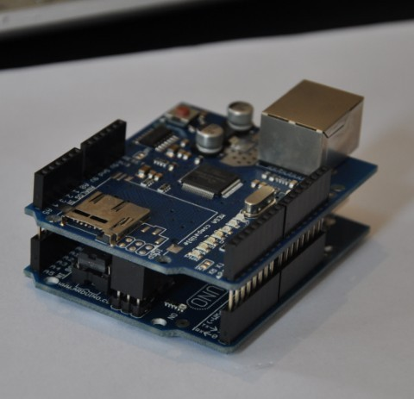
SIZE: L-69MM W-53.6MM
2.Download the test sketch
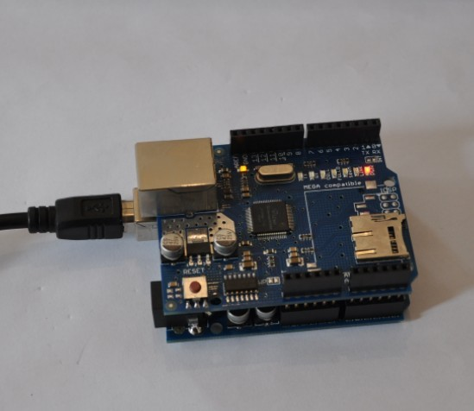
arduino w5100 test code:

/************************************************/
#include <SPI.h>
/*
* Web Server
*
* A simple web server that shows the value of the analog input pins.
*/
#include <Ethernet.h>
byte mac[] = { 0xDE, 0xAD, 0xBE, 0xEF, 0xFE, 0xED };
byte ip[] = { 192, 168, 0, 15 };
Server server(80);
void setup()
{
Ethernet.begin(mac, ip);
server.begin();
}
void loop()
{
Client client = server.available();
if (client) {
// an http request ends with a blank line
boolean current_line_is_blank = true;
while (client.connected()) {
if (client.available()) {
char c = client.read();
// if we've gotten to the end of the line (received a newline
// character) and the line is blank, the http request has ended,
// so we can send a reply
if (c == 'n' && current_line_is_blank) {
// send a standard http response header
client.println("HTTP/1.1 200 OK");
client.println("Content-Type: text/html");
client.println();
// output the value of each analog input pin
client.print("welcome to tinyos electronics");
client.println("<br />");
client.print("//*************************************");
client.println("<br />");
client.print("");
client.println("<br />");
client.print("//*************************************");
client.println("<br />");
for (int i = 0; i < 6; i++) {
client.print("analog input ");
client.print(i);
client.print(" is ");
client.print(analogRead(i));
client.println("<br />");
}
break;
}
if (c == 'n') {
// we're starting a new line
current_line_is_blank = true;
} else if (c != 'r') {
// we've gotten a character on the current line
current_line_is_blank = false;
}
}
}
client.stop();
}
}
/************************************************/
3.Connet your W5100 board and PC with cable(you may need a crossover cable if you direct connect PC and W5100)
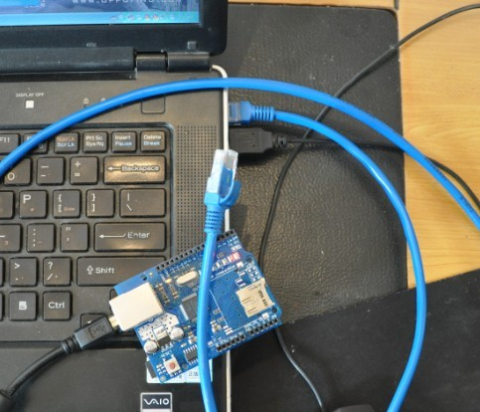
4. Setting your local PC IP
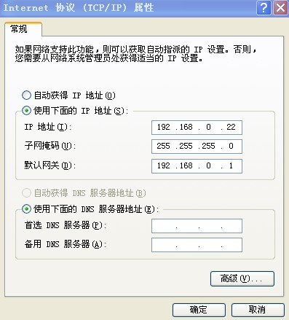
5.You will see PC Local connection show connected and W5100 4 LEDS will turn ON
FULLD,100M,LINK,PWR
If not please try to press RESET button on W5100 Shield.
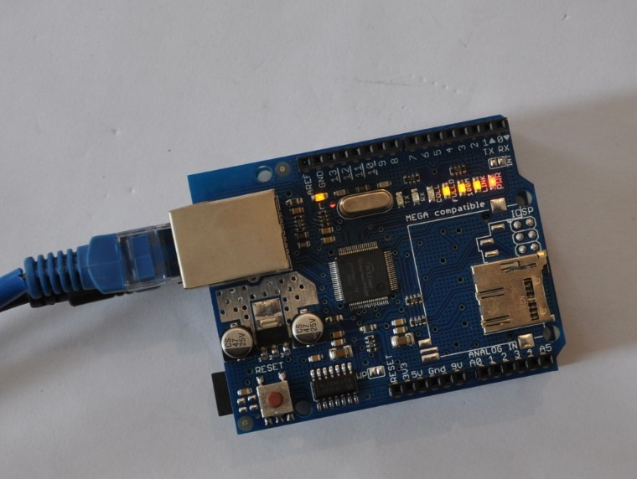

5.Now you can PING the W5100
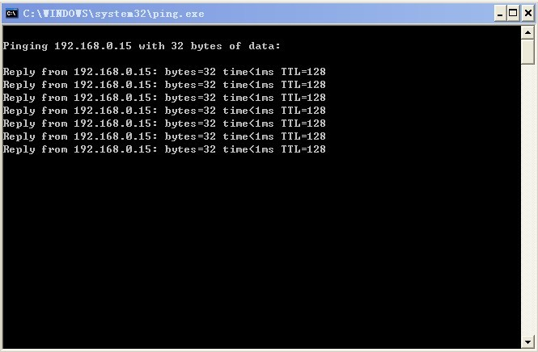
6.Visit http://192.168.0.15/ you can see the test web page
